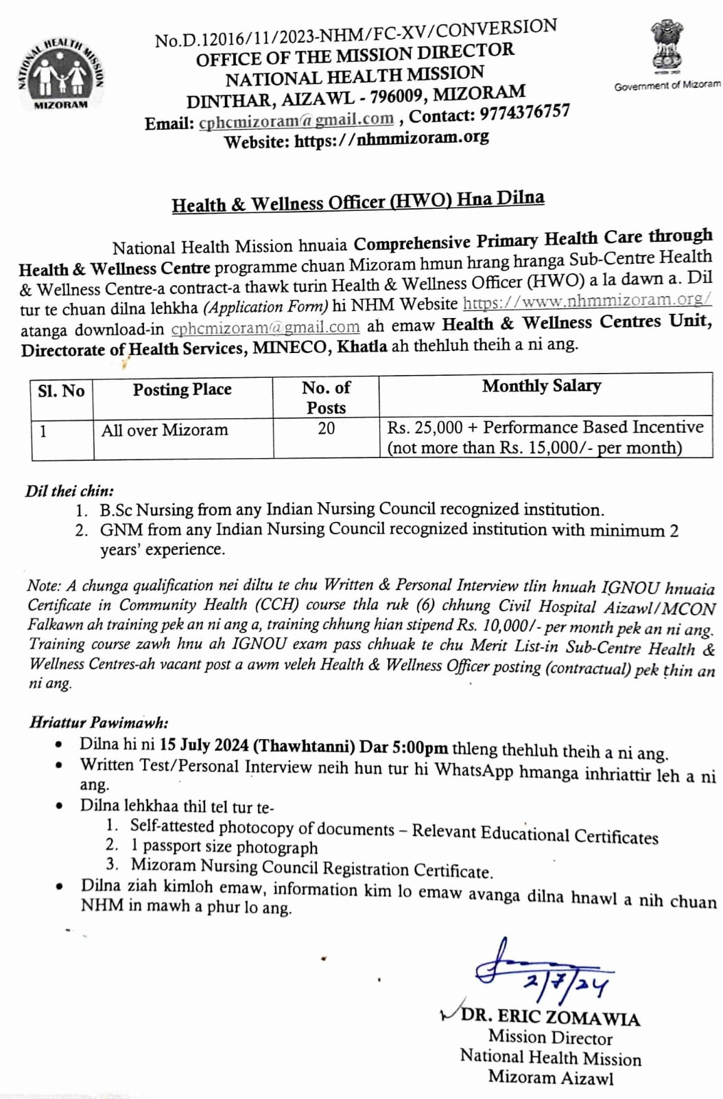

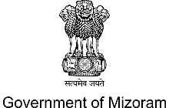**COMPREHENSIVE PRIMARY HEALTH CARE**

***Through***

**HEALTH & WELLNESS CENTRES (CPHC-HWC)**

**NATIONAL HEALTH MISSION**

**MIZORAM**

**Application for Health & Wellness Officer (HWO)**

**Name of Applicant:_______________________________________________________**

Affix 1 Passport size Photograph

**Father’s/Mother’s Name:__________________________________________________**

**Permanent Address:_______________________________________________________**

**Date of Birth:____________________________________________________________**

**Contact (WhatsApp & Call):_______________________________________________**

**Email:___________________________________________________________________**

**Mizoram Nursing Council Regn No:__________________________________________**

**Educational Qualification:***(From Class X up to recent qualification)*

|  |  |  |  |
| --- | --- | --- | --- |
| **Sl. No.** | **Name of Degree** | **Year of Passing** | **Name of Institution** |
|  |  |  |  |
|  |  |  |  |
|  |  |  |  |
|  |  |  |  |
|  |  |  |  |

**Experience:**

|  |  |  |  |
| --- | --- | --- | --- |
| **Sl. No.** | **Post Held/Designation** | **Duration** | **Name of Organization/Hospital** |
|  |  |  |  |
|  |  |  |  |
|  |  |  |  |
|  |  |  |  |
|  |  |  |  |

**Signature of Applicant : ( )**

**Date :**